**JavaScript : Array Lab Work**

1. What does the **length** property of an array return?

Number of elements

1. How do you convert an array to a string using the **toString()** method?

console.log(array.toString());

1. How do you access an element at a specific index in an array using the **at()** method?

It seems you might have mistaken it with other methods like Array[index] for accessing an element at a specific index.

 <script>

            const array = ["apple", "banana", "orange"];

            console.log(array.at(1));

    </script>

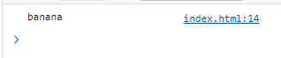

1. How do you concatenate all elements of an array into a string using the **join()** method?

Joins all elements of an array into a string using a specified separator.

 <script>

        const array = ["ren", "ghe", "son"];

        console.log(array.join(" - "));

    </script>



1. How do you remove the last element from an array using the **pop()** method?

<script>

      const array= ["ren", "ghe", "son"];

        array.pop(2);

        console.log(array);

    </script>



1. How do you add elements to the end of an array using the **push()** method?

Adds one or more elements to the end of an array and returns the new length of the array.

<script>

    const array= ["ren", "ghe", "son"];

    array.push("vil","van");

    console.log(array);

</script>



1. How do you delete an element at a specific index in an array using the **splice()** method?

Changes the contents of an array by removing or replacing existing elements and/or adding new elements in place.

<script>

    const array= ["ren", "ghe", "son","vil","van"];

    console.log(array.splice(1,2));

    console.log(array);

</script>

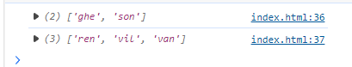

1. How do you concatenate two or more arrays using the **concat()** method?

<script>

    const  firstname = "renghe";

const lastname = "vilva";

const newArray =  firstname.concat(" " +lastname);

console.log(newArray);

</script>



1. How do you create a shallow copy of a portion of an array using the **slice()** method?

 <script>

      const array= ["ren", "ghe", "son","vil","van"];

    console.log(array.slice(0,3));

    console.log(array);

   </script>

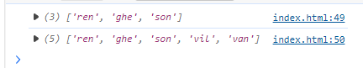

1. How do you sort the elements of an array using the **sort()** method?

<script>

    const array= ["ren", "ghe", "son","vil","van"];

  console.log(array.sort());

 </script>



1. How do you reverse the order of elements in an array using the **reverse()** method?

<script>

    const array= ["ren", "ghe", "son","vil","van"];

  console.log(array.reverse());

 </script>



1. How do you find the index of a specific element in an array using the **indexOf()** method?

<script>

    const array= ["ren", "ghe", "son","vil","van"];

  console.log(array.indexOf("vil"));

 </script>

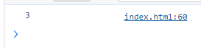

1. How do you check if an array includes a specific element using the **includes()** method?

<script>

    const array= ["ren", "ghe", "son","vil","van"];

  console.log(array.includes("vil"));

 </script>



Create the below web page using HTML and Javascript

Use Array Methods

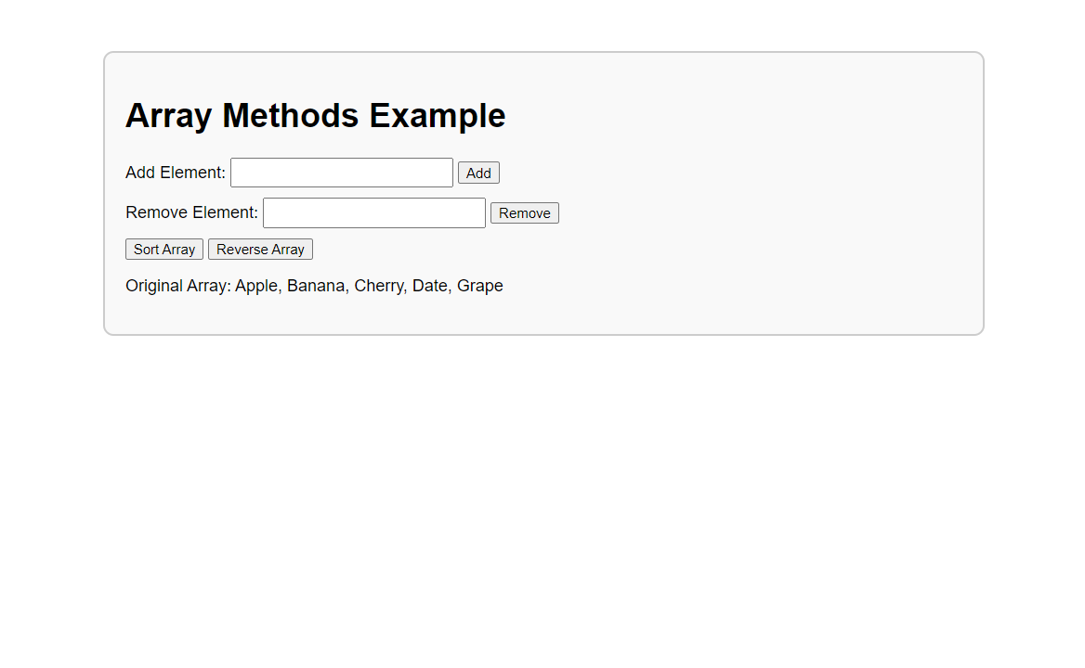

<h1>  Array Methods example </h1>

 <form action="demo">

    <label for="addEle"> Add Element </label>

    <input type="text" id="addEleinput">

    <button type="button"  onclick="addEle()"> Add</button> <br><br>

    <label for="addEle"> Remove Element: </label>

    <input type="text" id="reEleinput">

    <button type="button" onclick="rmov()"> Remove</button> <br><br>

    <button type="button" onclick="sort()"> Sort Array</button>

    <button type="button" onclick="reverse()"> reverse Array</button>

    <p id="outputs"></p>

 </form>

<script>

    let fruit = [ "apple" , "banana" , "Grape" , "Data" , "Cherry"]

    function outputArray(){

        document.getElementById("outputs").innerHTML = "original Array: " + fruit.join(" , ");

    }

    function addEle(){

        let newElement = document.getElementById("addEleinput").value;

        fruit.push(newElement) ;

        outputArray();

    }

    function rmov(){

        let newElementRemove = document.getElementById("reEleinput").value;

        let index = fruit.indexOf(newElementRemove);

        if (index !== -1) {

            fruit.splice(index,1);

        }

        outputArray();

    }

    function sort(){

        fruit.sort();

        outputArray();

    }

    function reverse(){

        fruit.reverse();

        outputArray();

    }

    outputArray();

</script>